# Comment Wall on Case Entity

## Overview

The activity feeds help promote internal collaboration through quick and short updates in Dynamics 365.

We have Auto Post and Manual Post (User Post) activity feeds in D365. A post generated by Dynamics 365 by applying an auto post rule in case of an event, such as creation of an account or closure of a won opportunity. An auto post can be shown on a record wall or personal wall.

This is the Auto Post created on Create of Case. We can also create a Manual Post by clicking on ‘+’ button on the Timeline. These posts act as a Comment Wall.

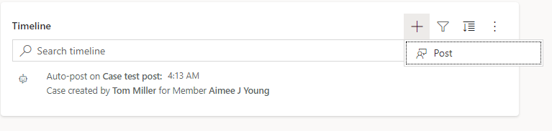

## Actions that can be done on Post

* Mentions: A part of a post that refers to a Dynamics 365 Customer Engagement record. One post can have multiple mentions.

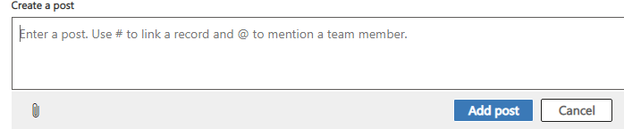

We can use ‘#’ to link a record and ‘@’ to mention a user or team member.

* Comment: A remark that is added on a post. A comment is related to a parent post. It cannot exist without a parent post. If a parent post is deleted, the post’s comments are deleted also.
* Follow: An action taken by a user on a Dynamics 365 record that enables that user to see the posts about the record on their personal wall.
* Unfollow: An action taken by a user on a Dynamics 365 record that stops posts about that record from being displayed on the user's personal wall.
* Like: An action taken by a user on a post that expresses that the user liked the post.
* Unlike: An action taken by a user to remove the Like from the post.

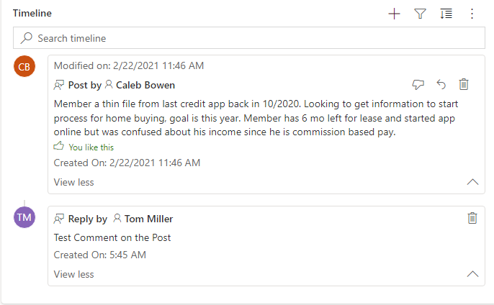

* Thread or Conversation: A collection of posts and all related comments.